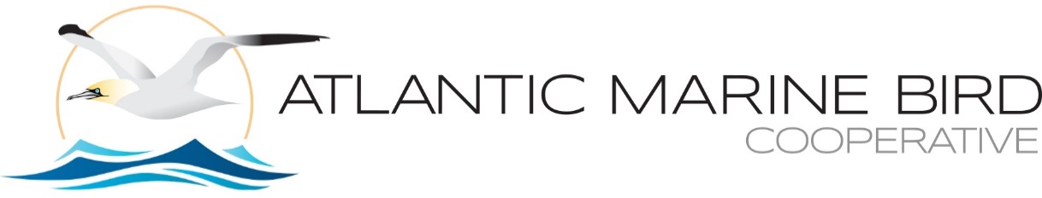

2023 Meeting - Agenda
Ft. Lauderdale, FL, October 9-11, 2023
(Waterbird Society Meeting)

Monday October 9, 2023 - 8:15am-5:10pm: General Meeting, Metropolitan Room

8:15a Indigenous Peoples Acknowledgement, Intros, Logistics & Agenda Review (30 min) - ALL

8:45a AMBC Overview, Website, and Updates (30 min) - Caleb Spiegel [Recording Part 1 - start]

9:15a Working Group Updates, Review of Team objectives & Breakout Meeting Goals (15 min/ea)
• Forage Fish - Linda Welch
• Seabird Colonies & Adjacent Waters (SCAW) - Ruth Boettcher
• Marine Spatial Planning - Holly Goyert
• Community Science & Marine Bird Health - Stephanie Avery-Gomm

10:15a BREAK [Recording Part 1- end]

10:30a World Seabird Union Update - Juliet Lamb (15 min) [Recording Part 2 - start]

10:45a AMBC Organization & Development (60 min)
• Steering Committee goings and comings - Caleb (5 min)
• Summary & accomplishment reporting: Call for 2023 submissions & process - Caleb (5 min)
• Recap of voting & decision-making processes - Caleb (5 min)
• Providing science-based comments/recommendations on behalf of AMBC - Iain Stenhouse (20 min)
• ‘State of the Seabirds’ : targeted outreach for seabirds - Scott Johnston (10 min)
• Other business - Caleb (15 min)
- Interest in new & revitalized working groups; Priority species list revision; 2024 meeting venue; etc.

11:45a LUNCH (on your own - several options w/in a short walk) [Recording Part 2 – end]

1:15p Working Group Breakouts - Session 1 (concurrent, choose one): [Recording Part 3 – start]
1) Marine Spatial Planning (Compensatory Mitigation focus) - Holly
[2) Community Science and Marine Bird Health – Stephanie – not recorded]

2:45p BREAK [Recording Part 3 – end]

3:00p Working Group Breakouts - Session 2 (Combo session, single group) [Recording Part 4 – start]
Forage Fish & Seabird Colonies and Adjacent Waters COMBINED - Linda & Ruth

4:30p Brief Working Group Session Report Outs (10 min ea/ group) & AMBC Org Session (continued)

5:10p ADJOURN [Recording Part 4 - end]
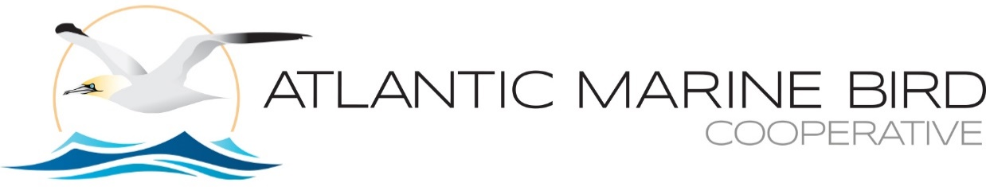

Tuesday October 10, 2023 (each time slot - 15 minutes) [Talks not recorded]

1:00-3:00 pm: AMBC Presentations Symposium Session I, Ballroom A
1) I. Stenhouse, et al. - Developing guidance for pre- and post-construction monitoring to detect changes in marine bird distributions and habitat use related to offshore wind development
2) J. Lamb - A synthetic analysis of post-construction displacement and attraction of marine birds at offshore wind energy installations
3) M. Scott - History of marine wildlife digital aerial surveying
4) H. Skov, et al. - Comparable avoidance behaviour of seabirds measured at three offshore wind farms in the Northwest Atlantic (US), United Kingdom (Scotland) and eastern North Sea (Netherlands)
5) J. Robinson Willmott, et. al - New insights into the influence of turbines on the behavior of migrant birds: implications for predicting impacts of offshore wind developments on wildlife
6) J. Stucker, et al. - Results from testing - A Multi-Sensor Approach for Measuring Bird and Bat Collisions with Wind Turbines
7) H. Goyert, et al. - Avian risk assessment to support New York’s Offshore Wind Master Plan 2.0: Deep Water
8) J.C. Haney, et al. - Flight behaviors in subtropical seabirds exacerbate collision risk for wind energy development in deep-water environments

3:00-3:30 pm - BREAK

3:30-5:00 pm: AMBC Presentations Symposium Session I (cont.), Ballroom A
1) J. Gleason, et al. - The Gulf of Mexico Avian Monitoring Network (GoMAMN): a brief history of a value-driven bird monitoring community of practice in the wake of the Deepwater Horizon oil spill
2) J. Gleason, et al. - GoMAMN questions & discussion; Coordination with AMBC?
3) P. Michael, et al. - Migration, breeding location, and seascape shape seabird assemblages in the northern Gulf of Mexico
4) Y. Satgé, et al. - Update on the forthcoming Gulf of Mexico nesting waterbird atlas and registry
5) K. Sutherland - Stable Isotope and Mercury Analysis of Black-capped Petrel (Pterodroma hasitata) Feathers to Investigate Trophic Position and Foraging Areas of Light, Dark, and Intermediate Forms
6) S. Wong, et al. - The Nunatsiavut Seabird Tracking Program: Understanding the year-round movements of seabirds breeding in Nunatsiavut waters

Wednesday October 11, 2023 (each time slot - 15 minutes) [Talks not recorded]

10:00am-11:30 am: AMBC Presentations Symposium Session II, Ballroom A
1) K. Peters, et al. - Exploring environmental compensation measures for offshore wind: black-legged kittiwake in the U.K.
2) I. Pakzad - Identifying longline vessel related fishing tactics that impact seabird bycatch risk
3) J. Spendelow - A preliminary look at comparative use of staging sites at Cape Cod National Seashore by Hatch Year Roseate and Common Terns from colony sites where these species nest sympatrically
4) Tatsiana Barychka, et al. - iNaturalist: Benefits and challenges of using a citizen science tool to understand mortality events in the Western Hemisphere.
5) Sabina Wilhelm, et al. - Year 1 after the 2022 Highly Pathogenic Avian Influenza (HPAI) outbreak in eastern Canada: Assessing population impacts on seabirds breeding in Atlantic Canada
6) Liam Taylor, et. al - Real-time monitoring of highly pathogenic avian influenza virus A(H5N1) at a seabird colony reveals details of wild disease outbreaks

